**Working with Scripted Pipeline**

**1 .Modify the Jenkinsfile as required and commit it locally:**

[root@ip-172-31-32-46 CICD]# vi **Jenkinsfile**

[root@ip-172-31-32-46 CICD]# git add Jenkinsfile

[root@ip-172-31-32-46 CICD]# git commit -m "Adding Jenkinsfile"

[master 0152314] Adding Jenkinsfile

1 file changed, 39 insertions(+)

create mode 100644 Jenkinsfile

**2. Push the changes back to GitHub Repository**

[root@ip-172-31-32-46 CICD]#

[root@ip-172-31-32-46 CICD]# git push origin master

Counting objects: 3, done.

Compressing objects: 100% (3/3), done.

Writing objects: 100% (3/3), 739 bytes | 739.00 KiB/s, done.

Total 3 (delta 1), reused 0 (delta 0)

remote: Resolving deltas: 100% (1/1), completed with 1 local object.

remote:

remote: GitHub found 2 vulnerabilities on chaitanyagaajula/CICD's default branch (1 moderate, 1 low). To find out more, visit:

remote: https://github.com/chaitanyagaajula/CICD/network/alerts

remote:

To github.com:chaitanyagaajula/CICD.git

3b003c0..0152314 master -> master

[root@ip-172-31-32-46 CICD]#

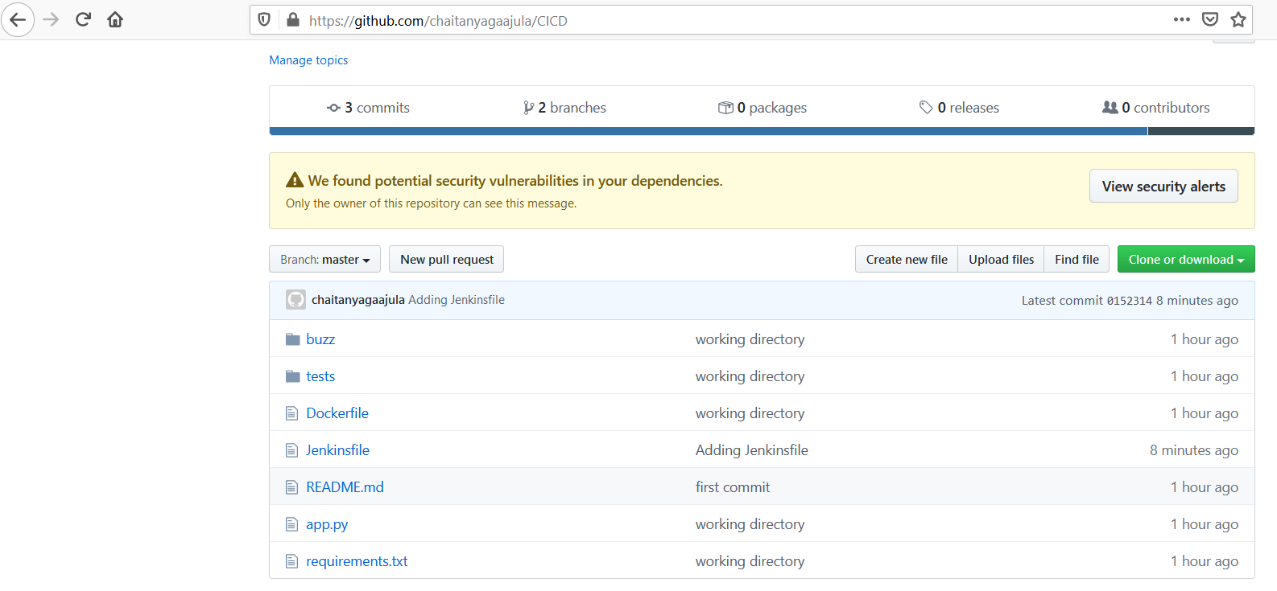

3. Create a new Project_2 and choose type as Pipeline and Click on OK

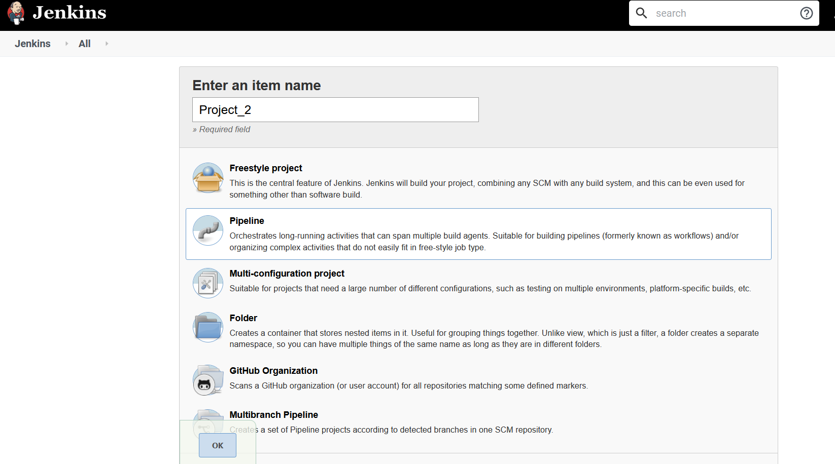

4. Click on Pipeline tab and choose option “Pipelinescript from SCM” under definition and provide the repository details along with the credentials and Click on Apply and Save.

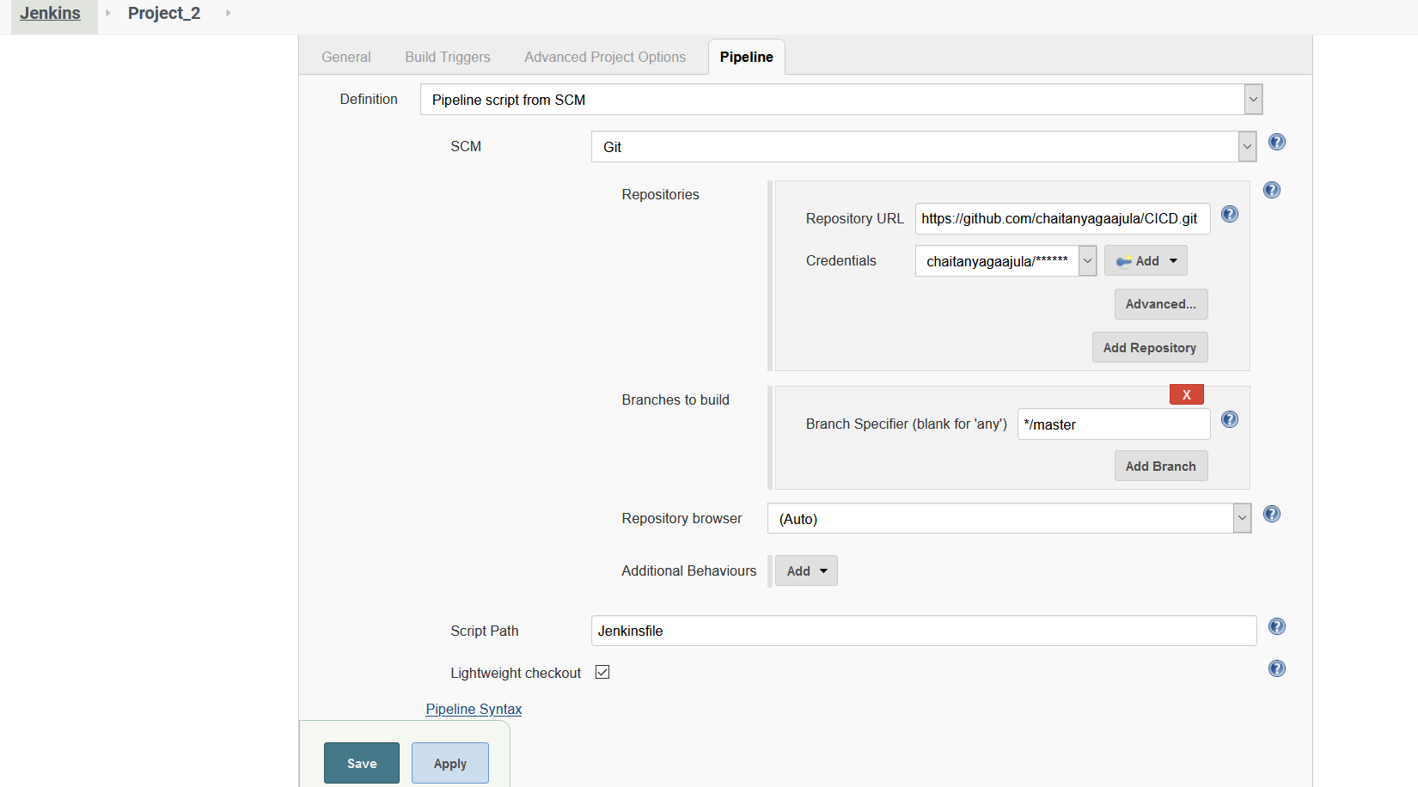

5. Back to Dashboard and Click on Build now and observe the o/p under “ Full Stage View”run

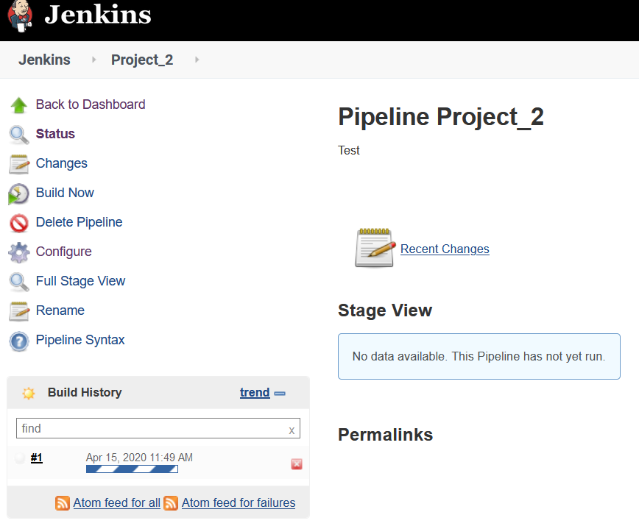

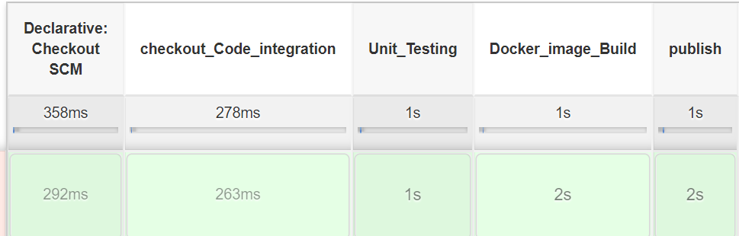

**Console Output:**

Started by user [admin](http://3.81.107.248:8080/user/admin)

Obtained Jenkinsfile from git <https://github.com/chaitanyagaajula/CICD.git>

Running in Durability level: MAX_SURVIVABILITY

[Pipeline] Start of Pipeline

[Pipeline] node

Running on [Jenkins](http://3.81.107.248:8080/computer/(master)/) in /var/lib/jenkins/workspace/Project_2

[Pipeline] {

[Pipeline] stage

[Pipeline] { (Declarative: Checkout SCM)

[Pipeline] checkout

using credential GIT_chait

Cloning the remote Git repository

Cloning repository <https://github.com/chaitanyagaajula/CICD.git>

> git init /var/lib/jenkins/workspace/Project_2 # timeout=10

Fetching upstream changes from <https://github.com/chaitanyagaajula/CICD.git>

> git --version # timeout=10

using GIT_ASKPASS to set credentials

> git fetch --tags --progress -- <https://github.com/chaitanyagaajula/CICD.git> +refs/heads/*:refs/remotes/origin/* # timeout=10

> git config remote.origin.url <https://github.com/chaitanyagaajula/CICD.git> # timeout=10

> git config --add remote.origin.fetch +refs/heads/*:refs/remotes/origin/* # timeout=10

> git config remote.origin.url <https://github.com/chaitanyagaajula/CICD.git> # timeout=10

Fetching upstream changes from <https://github.com/chaitanyagaajula/CICD.git>

using GIT_ASKPASS to set credentials

> git fetch --tags --progress -- <https://github.com/chaitanyagaajula/CICD.git> +refs/heads/*:refs/remotes/origin/* # timeout=10

> git rev-parse refs/remotes/origin/master^{commit} # timeout=10

> git rev-parse refs/remotes/origin/origin/master^{commit} # timeout=10

Checking out Revision 015231453ccf9d51b8eeafd7910b41de1ee915fa (refs/remotes/origin/master)

> git config core.sparsecheckout # timeout=10

> git checkout -f 015231453ccf9d51b8eeafd7910b41de1ee915fa # timeout=10

Commit message: "Adding Jenkinsfile"

First time build. Skipping changelog.

[Pipeline] }

[Pipeline] // stage

[Pipeline] withEnv

[Pipeline] {

[Pipeline] stage

[Pipeline] { (checkout_Code_integration)

[Pipeline] checkout

using credential GIT_chait

> git rev-parse --is-inside-work-tree # timeout=10

Fetching changes from the remote Git repository

> git config remote.origin.url <https://github.com/chaitanyagaajula/CICD.git> # timeout=10

Fetching upstream changes from <https://github.com/chaitanyagaajula/CICD.git>

> git --version # timeout=10

using GIT_ASKPASS to set credentials

> git fetch --tags --progress -- <https://github.com/chaitanyagaajula/CICD.git> +refs/heads/*:refs/remotes/origin/* # timeout=10

> git rev-parse refs/remotes/origin/master^{commit} # timeout=10

> git rev-parse refs/remotes/origin/origin/master^{commit} # timeout=10

Checking out Revision 015231453ccf9d51b8eeafd7910b41de1ee915fa (refs/remotes/origin/master)

> git config core.sparsecheckout # timeout=10

> git checkout -f 015231453ccf9d51b8eeafd7910b41de1ee915fa # timeout=10

Commit message: "Adding Jenkinsfile"

[Pipeline] }

[Pipeline] // stage

[Pipeline] stage

[Pipeline] { (Unit_Testing)

[Pipeline] sh

+ /usr/local/bin/pip install -r requirements.txt

DEPRECATION: Python 2.7 reached the end of its life on January 1st, 2020. Please upgrade your Python as Python 2.7 is no longer maintained. A future version of pip will drop support for Python 2.7. More details about Python 2 support in pip, can be found at <https://pip.pypa.io/en/latest/development/release-process/#python-2-support>

Defaulting to user installation because normal site-packages is not writeable

Requirement already satisfied: pytest==3.0.6 in /usr/local/lib/python2.7/site-packages (from -r requirements.txt (line 1)) (3.0.6)

Requirement already satisfied: Flask==0.12 in /usr/local/lib/python2.7/site-packages (from -r requirements.txt (line 2)) (0.12)

Requirement already satisfied: py>=1.4.29 in /usr/local/lib/python2.7/site-packages (from pytest==3.0.6->-r requirements.txt (line 1)) (1.8.1)

Requirement already satisfied: setuptools in /usr/lib/python2.7/dist-packages (from pytest==3.0.6->-r requirements.txt (line 1)) (36.2.7)

Requirement already satisfied: Jinja2>=2.4 in /usr/lib/python2.7/dist-packages (from Flask==0.12->-r requirements.txt (line 2)) (2.7.2)

Requirement already satisfied: click>=2.0 in /usr/local/lib/python2.7/site-packages (from Flask==0.12->-r requirements.txt (line 2)) (7.1.1)

Requirement already satisfied: itsdangerous>=0.21 in /usr/local/lib/python2.7/site-packages (from Flask==0.12->-r requirements.txt (line 2)) (1.1.0)

Requirement already satisfied: Werkzeug>=0.7 in /usr/local/lib/python2.7/site-packages (from Flask==0.12->-r requirements.txt (line 2)) (1.0.1)

Requirement already satisfied: markupsafe in /usr/lib64/python2.7/dist-packages (from Jinja2>=2.4->Flask==0.12->-r requirements.txt (line 2)) (0.11)

[Pipeline] sh

+ /usr/bin/python3 -m pytest -v tests/test_generator.py

============================= test session starts ==============================

platform linux -- Python 3.6.10, pytest-3.0.6, py-1.8.1, pluggy-0.4.0 -- /usr/bin/python3

cachedir: .cache

rootdir: /var/lib/jenkins/workspace/Project_2, inifile:

collecting ... collected 3 items

tests/test_generator.py::test_sample_single_word PASSED

tests/test_generator.py::test_sample_multiple_words PASSED

tests/test_generator.py::test_generate_buzz_of_at_least_five_words PASSED

=========================== 3 passed in 0.02 seconds ===========================

[Pipeline] }

[Pipeline] // stage

[Pipeline] stage

[Pipeline] { (Docker_image_Build)

[Pipeline] sh

+ /usr/bin/docker build -t chaitanyagaajula/cicd-example:latest .

Sending build context to Docker daemon 103.9kB

Step 1/7 : FROM alpine:3.5

---> f80194ae2e0c

Step 2/7 : RUN apk add --update python py-pip

---> Using cache

---> c17e5ab45038

Step 3/7 : COPY requirements.txt /src/requirements.txt

---> Using cache

---> ec176f380882

Step 4/7 : RUN pip install -r /src/requirements.txt

---> Using cache

---> 85df5197cba6

Step 5/7 : COPY app.py /src

---> Using cache

---> 856a413f7636

Step 6/7 : COPY buzz /src/buzz

---> 2ef3379eaf6d

Step 7/7 : CMD python /src/app.py

---> Running in 15efc5632ed1

Removing intermediate container 15efc5632ed1

---> 4dd0731f30d1

Successfully built 4dd0731f30d1

Successfully tagged chaitanyagaajula/cicd-example:latest

[Pipeline] }

[Pipeline] // stage

[Pipeline] stage

[Pipeline] { (publish)

[Pipeline] withDockerRegistry

$ docker login -u chaitanyagaajula -p ******** <https://index.docker.io/v1/>

WARNING! Using --password via the CLI is insecure. Use --password-stdin.

WARNING! Your password will be stored unencrypted in /var/lib/jenkins/workspace/Project_2@tmp/581cc813-6c77-45d1-aed5-794dba7550ab/config.json.

Configure a credential helper to remove this warning. See

<https://docs.docker.com/engine/reference/commandline/login/#credentials-store>

Login Succeeded

[Pipeline] {

[Pipeline] sh

+ /usr/bin/docker push chaitanyagaajula/cicd-example:latest

The push refers to repository [docker.io/chaitanyagaajula/cicd-example]

5e5d1e7f9531: Preparing

846abbfbb79a: Preparing

50fe25d6ada3: Preparing

ef29c20ef5b8: Preparing

20a7bd37f012: Preparing

f566c57e6f2d: Preparing

f566c57e6f2d: Waiting

846abbfbb79a: Layer already exists

ef29c20ef5b8: Layer already exists

50fe25d6ada3: Layer already exists

20a7bd37f012: Layer already exists

f566c57e6f2d: Layer already exists

5e5d1e7f9531: Pushed

latest: digest: sha256:1c99df1880bee978877ae44efc7a2270e8969e039297ed7aa41046de4304cf42 size: 1573

[Pipeline] }

[Pipeline] // withDockerRegistry

[Pipeline] }

[Pipeline] // stage

[Pipeline] stage

[Pipeline] { (Running_image_from_DockerHub)

[Pipeline] sh

+ /usr/bin/docker run -p 5000:5000 --rm chaitanyagaajula/cicd-example:latest

* Running on <http://0.0.0.0:5000/> (Press CTRL+C to quit)



**Output:**

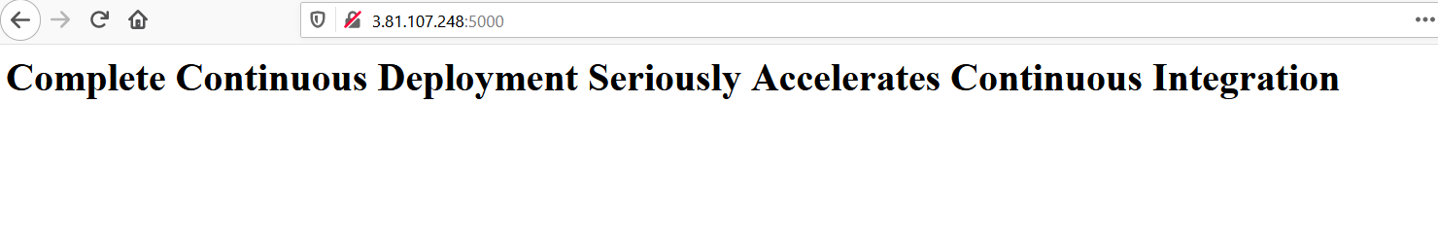

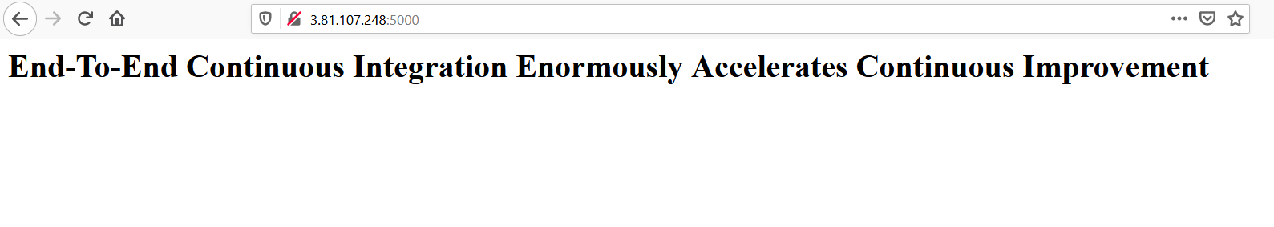

**Stopping the application:**

[root@ip-172-31-32-46 ~]# docker container ls

CONTAINER ID IMAGE COMMAND CREATED STATUS PORTS NAMES

4d487ff08a70 chaitanyagaajula/cicd-example:latest "/bin/sh -c 'python …" 4 minutes ago Up 4 minutes 0.0.0.0:5000->5000/tcp happy_mendeleev

[root@ip-172-31-32-46 ~]# docker stop happy_mendeleev

happy_mendeleev

[root@ip-172-31-32-46 ~]#